Decentralized Electronic Voting System using Blockchain and Smart Contracts

INTRODUCTION:

In every democracy, the security of an election is a matter of national security. The computer security field has for a decade studied the possibilities of electronic voting systems, with the goal of minimizing the cost of having a national election,
while fulfilling and increasing the security conditions of an election.

Electronic voting machines have been viewed as flawed, by the security community, primarily based on physical security concerns. Anyone with physical access to such machine can sabotage the machine, thereby affecting all votes cast on the aforementioned machine.

A blockchain is a distributed, immutable, incontrovertible, public ledger. This new technology works through four main features:
- The ledger exists in many different locations: No single
point of failure in the maintenance of the distributed
ledger.
- There is distributed control over who can append new
transactions to the ledger.
- Any proposed “new block” to the ledger must reference
the previous version of the ledger, creating an immutable
chain from where the blockchain gets its name, and
thus preventing tampering with the integrity of previous
entries.
- A majority of the network nodes must reach a consensus
before a proposed new block of entries becomes a
permanent part of the ledger.

PROPOSED SOLUTION:

We propose a Blockchain based solution for solving various problems faced in the voting process. This project is a simple attemmpt to design and build an electronic voting system; where we make use of Ethereum Smart Contracts to create a decentralized voting application (Dapp).

Our implementation consists of a web interface to allow user to interact with the blockchain, ReactJS as font-end and NodeJS as back-end. Connected to Ethereum Smart Contract via WEB3.

This project is inspired by https://skemman.is/bitstream/1946/31161/1/Research-Paper-BBEVS.pdf
SYSTEM DESIGN:

At a very high level, a simple voting system comprises of an organising authority( Election Commission) , a voting machine and a vote. In case of our system, we add an etherium based blockchain, which establishes the network between the three mentioned entities.

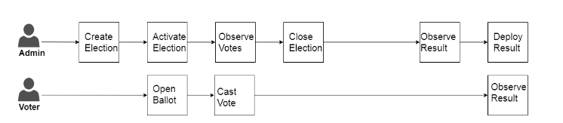
Ultimately our project converges a Decentralised Web application(). The components of this application are:
- Front-end system for Election Commission or Voting Machine
- Voter Validation
- Smart Contracts

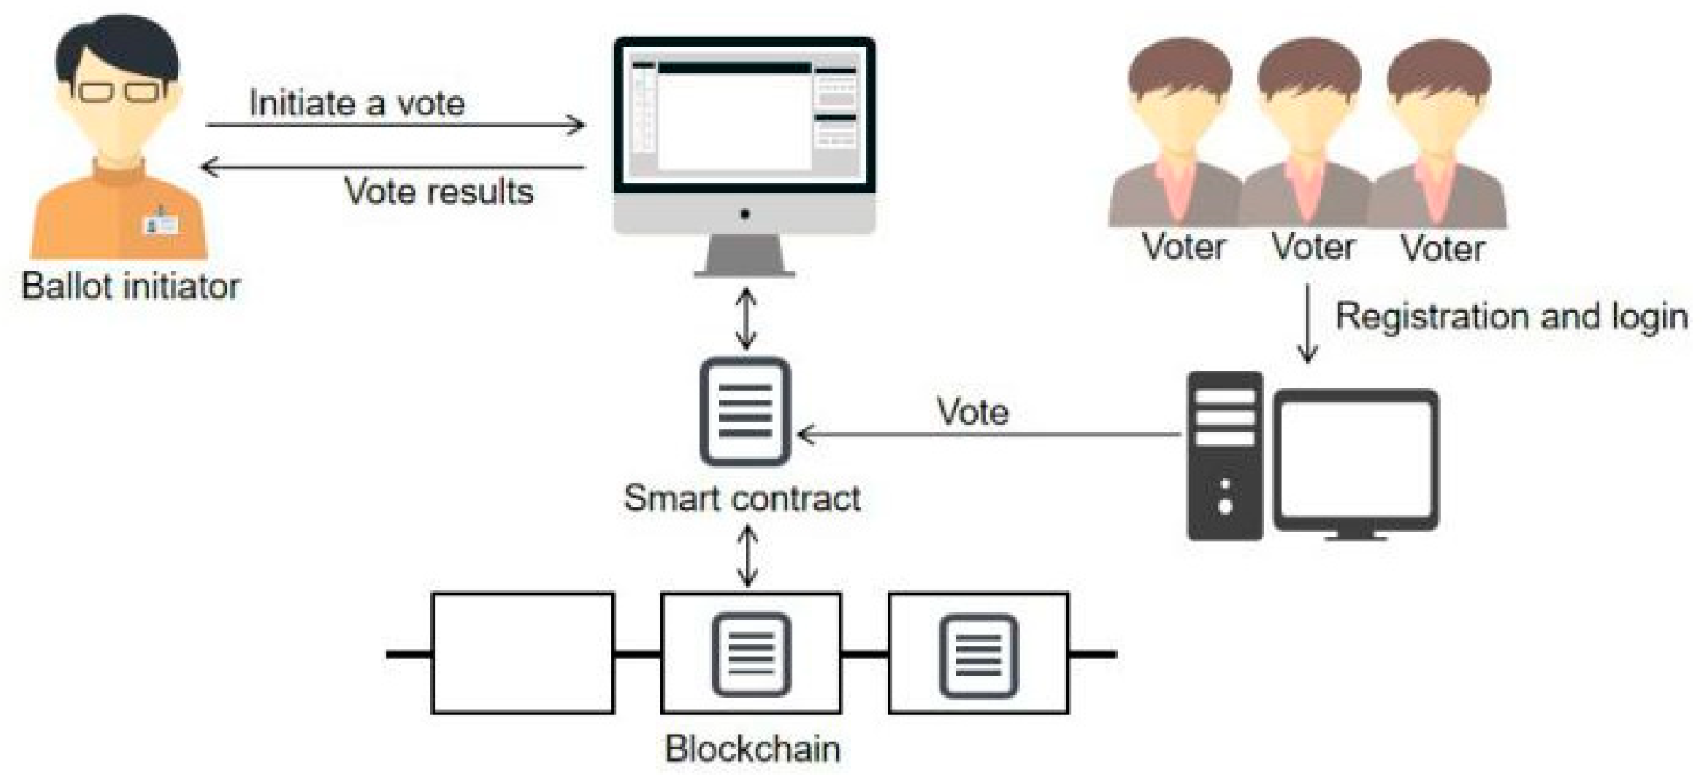

SMART CONTRACT:

Ballot smart contract. the Ballot smart contract is where the votes are recorded. The Ballot instance is deployed on the blockchain; and it consists a list of candidate data for populated when the contract is initially deployed.
The Contract has three states i.e. Start Vote, Voting, and End Vote. The Ballot consist of a vote function which can be called by the client to increment vote count of a candidate.
Since this function changes the state of the contract, it is function is payable, and thus recorded on the blockchain. This contract will be accessed by the voting application for voting.
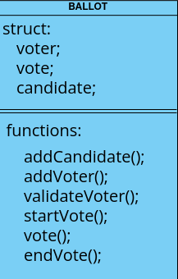

WEB CLIENT:

The system is designed with the following assumptions:
- The candidates are added by the ballator to the contract. For now we have hard coded the candidates in the contract for testing purpose.
- There is a voter authentication system integrated to the contract (NADRA). For now we are using some hard coded values for testing purpose.

The Voter has to enter the CNIC after which he is validated and can cast the vote to it’s desired candidate.

VOTER AUTHENTICATION SERVICE:
The Voter will enter the cnic and will be authenticated by entering a pin sent to his phone. Currently we have pushed the values from back-end for testing purpose. This can be fetched from front-end as well when there will be an external validation system integrated with the application.

BLOCKCHAIN:
The blockchain is established using remix. The contract is deployed on remix and we have integrated it to our Web client via ABI key provided by remix. The transaction data can be viewed and fetched from remix. For Transaction logging we have used Ganache.

